The E-Commerce DJANGO Application
This is a working mini e-commerce site where users can browse products, filter by category, add items to a cart, adjust quantities, and view orders. This Website uses the Django web framework.
Users can:
- View the home page
- Browse all products
- Filter products by category
- Open a single product detail page
- Add products to a cart
- Remove products from the cart
- Increase or decrease item quantities in the cart
- See cart totals
- View an orders page
- Use the Django admin panel if a superuser is created
It does not yet include:
- checkout/payment processing
- user login/logout
- placing an order from the cart
- saving cart contents permanently to the database
- shipping workflow
- inventory deduction
- product search by keyword

To Begin, How to Run the ECommerce Django Project in VS Code
- Download the project folder.
- Extract (unzip) the folder.
- Open VS Code.
- Go to File > Add Folder to Workspace and select the extracted Ecommerce project folder.
- Locate the .venv folder, right-click it, and choose 'Open in Integrated Terminal'. This places your virtual environment in the correct path location.
  - If (.venv) is not displayed in the terminal prompt, activate the virtual environment by typing ./Scripts/Activate.ps1
- Install Django by typing pip install django
- Install Pillow by typing pip install pillow
- Change your directory to Ecommerce by typing cd.. – your prompt should show you in the Ecommerce folder with a (.venv) preceding the PowerShell prompt
- Make sure the SQLite3 extension is installed in VS Code. You may wish to also ensure your database is set up by typing: python manage.py migrate (use python3 if you are on a MAC or Linux).
- Run the server: python manage.py runserver (on Macintosh or Linux use Python3 instead of Python)
- Open a browser and go to http://127.0.0.1:8000/
“Always activate your virtual environment before installing packages, or your project won’t be able to use them.”
NOTE: If virtual environment activation fails in step 5, run this first:
Set-ExecutionPolicy -Scope Process -ExecutionPolicy Bypass
What is 127.0.0.1?
- 127.0.0.1 is called the loopback address (or localhost)
- It always refers to your own computer
- So, the browser is not going out to the internet, it’s talking to the local Django server
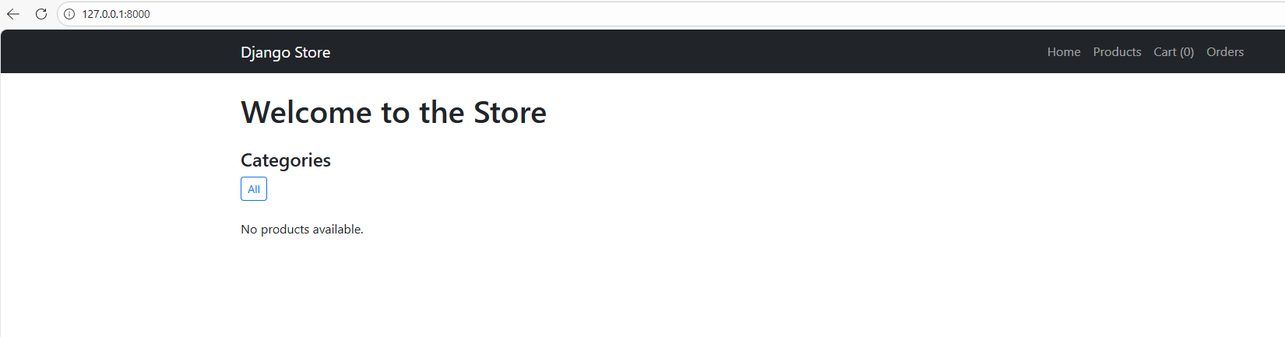

What Happens
1. Student types: http://127.0.0.1:8000/
2. Browser sends an HTTP request
3. Request goes to local machine (loopback)
4. Django development server receives it
5. Django processes the request using views.py
6. Django queries the database (if needed)
7. Django renders an HTML template
8. Response is sent back to the browser
9. Browser displays the webpage

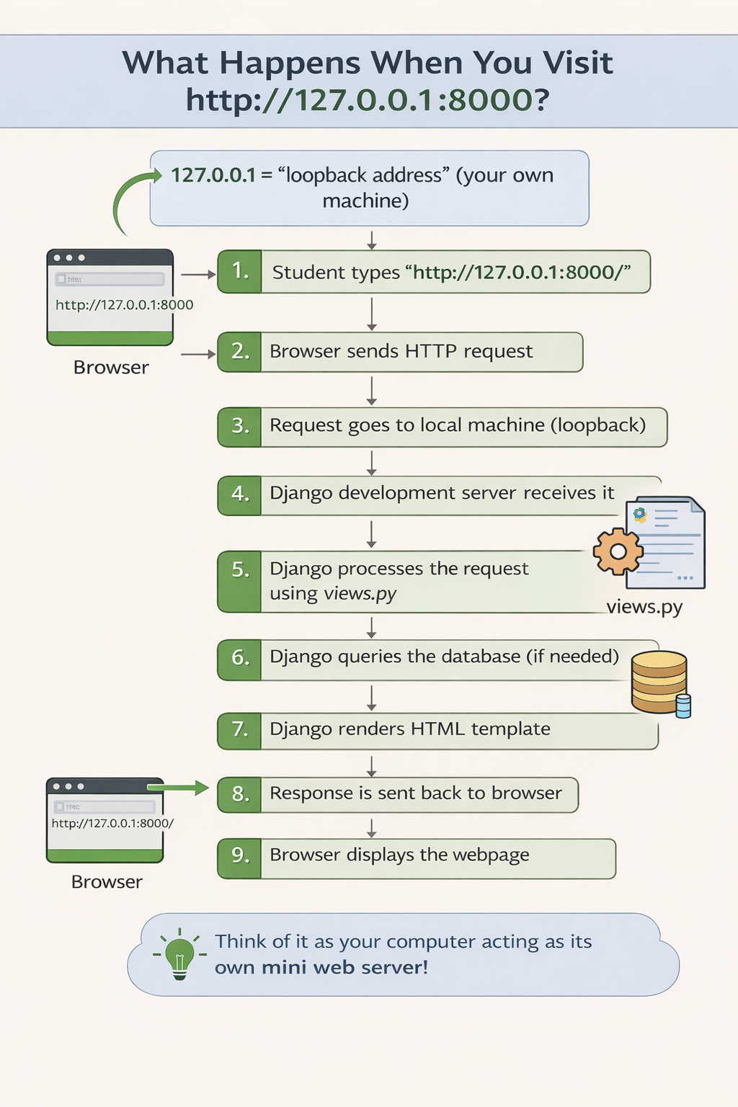
There is not much to look at on the website now until you begin your work so you may close the browser tab and exit the application in the VS Code .venv terminal by typing CTL-C to return to the prompt.
Your directory structure should appear as follows in VS Code:
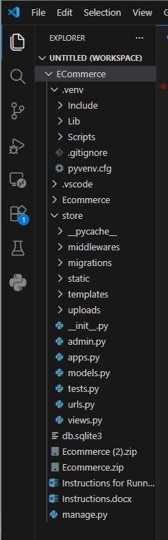

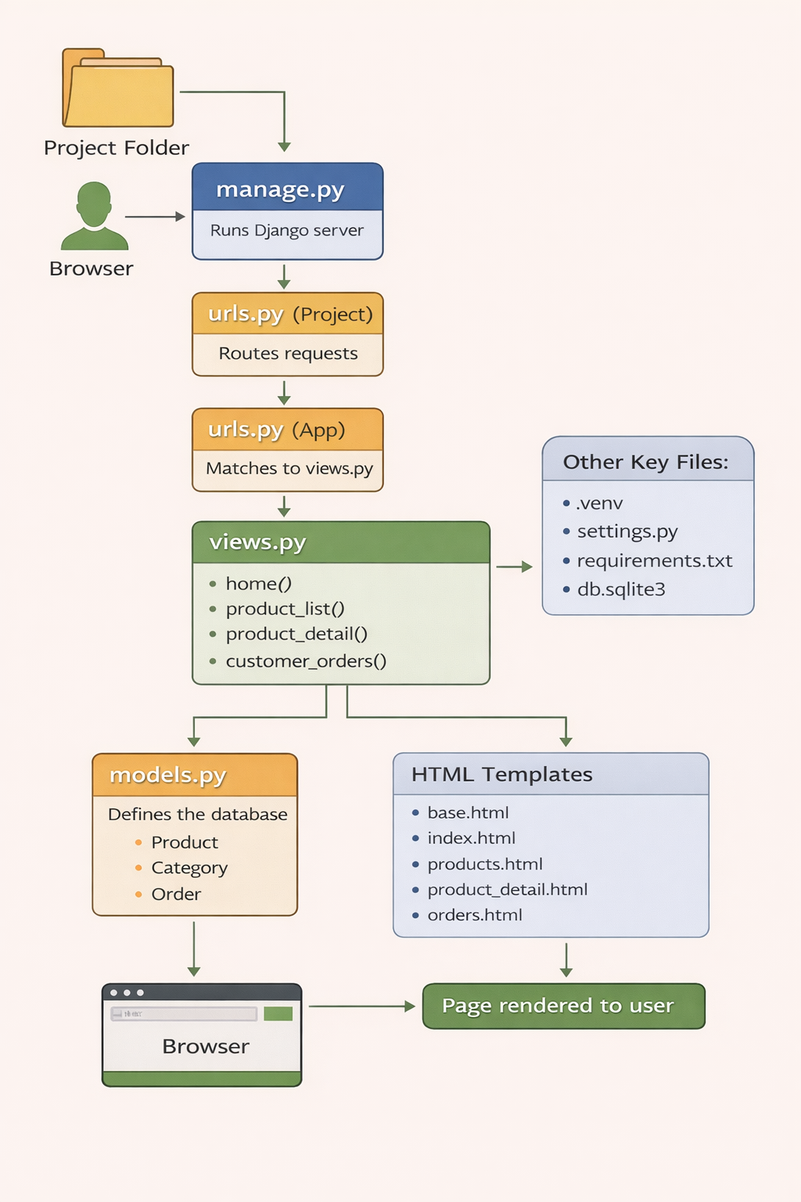

Admin.py - admin.py customizes how your data looks and behaves inside the Django admin dashboard.”

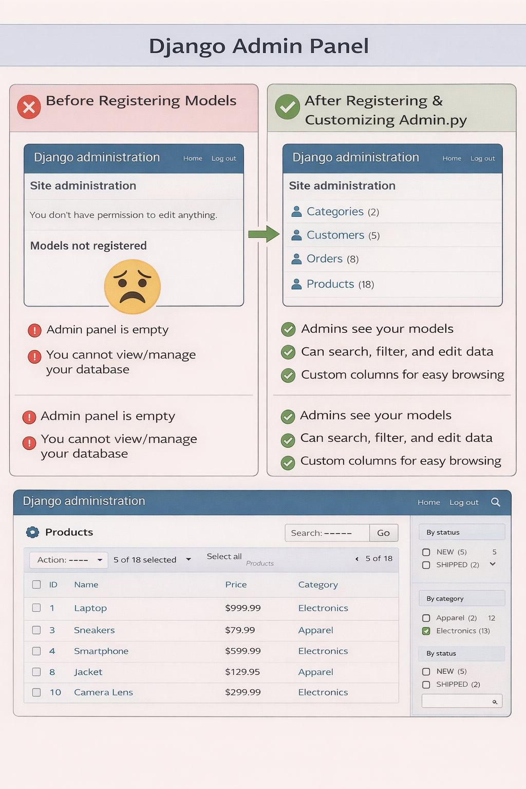

Apps.py – this file registers and describes your app inside the Django project

Models.py – Defines the database structure for the application. Each class becomes a table in the database.



